VILLAINS!!!

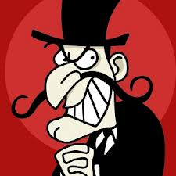

- Give your villain a shady past: what terrible things has your villain done throughout his or her life. Some villains are just trouble makers; others are deranged psychopaths. How extreme is your villain?
- Identify the source: what happened to your villain to turn him or her so evil? Was your villain born that way?
- The most interesting villains are not completely evil. They have a soft spot for puppies or they write cheesy love poems. Contrary personality traits add depth and realism to all characters. Describe your villain’s positive traits.

- What does your villain look like???? Draw him/her or describe with words. Give him/her a name.
- Put your villain in a scene: make sure you include dialogue so you can work out how the character speaks. Give your villain a distinct voice. Is your villain disguised as a kind character or does he or she spend every waking minute committing evil deeds.

