Scene depiction assignment
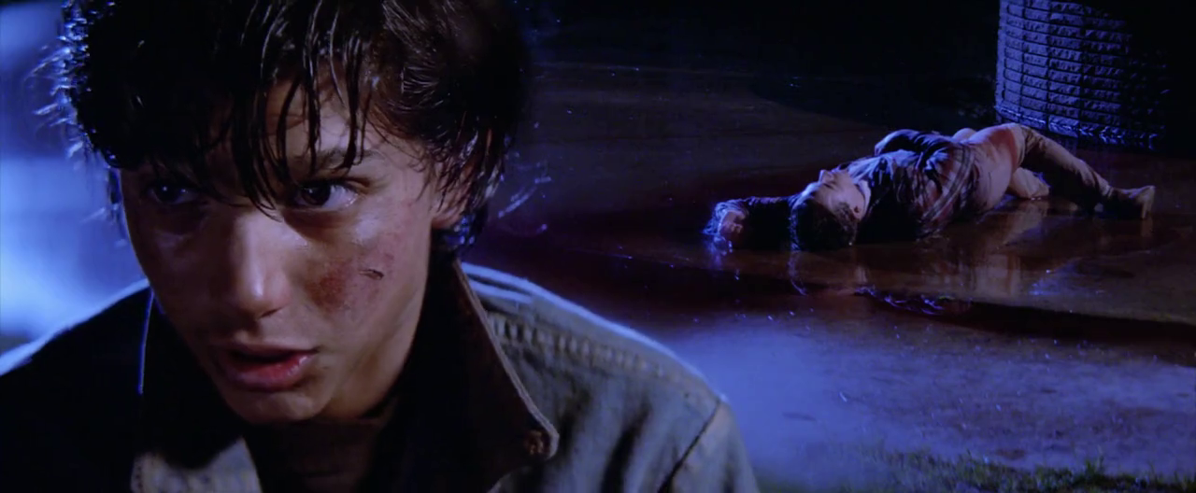
Bring a vivid scene to life with art. Select a scene from The Outsiders that has strong imagery, one that you could clearly see in your mind’s eye and draw/paint/sketch it—choose any technique way that best shows your perspective of the scene. Here’s how the score will be broken down.

50%= Effort. Shows neatness and attention to detail. Has color unless otherwise specified….

25%= Uses the actual quote from the story and is displayed on the piece.

25%= Is turned in on time. Must be present for the Art Show Thursday before class starts!

