A helicopter is a type of aircraft. It uses spinning wings called blades to fly. These rotating blades, or rotary blades, make up the helicopter's rotor system, which lets helicopters do things airplanes cannot.

How Does A Helicopter Work?
In order to fly, an object must have "lift." Lift is what pushes something up, and it is made by wings that have a curved shape on top and are flatter on the bottom. That shape makes air flow over the top faster than under the bottom. The faster air on top of the wing makes suction on the top of the wing and the wing moves up. Airplanes get lift from their wings. A helicopter's rotor blades are spinning wings. A helicopter moves air over its rotor by spinning the blades. The rotor makes the lift that carries the helicopter up.
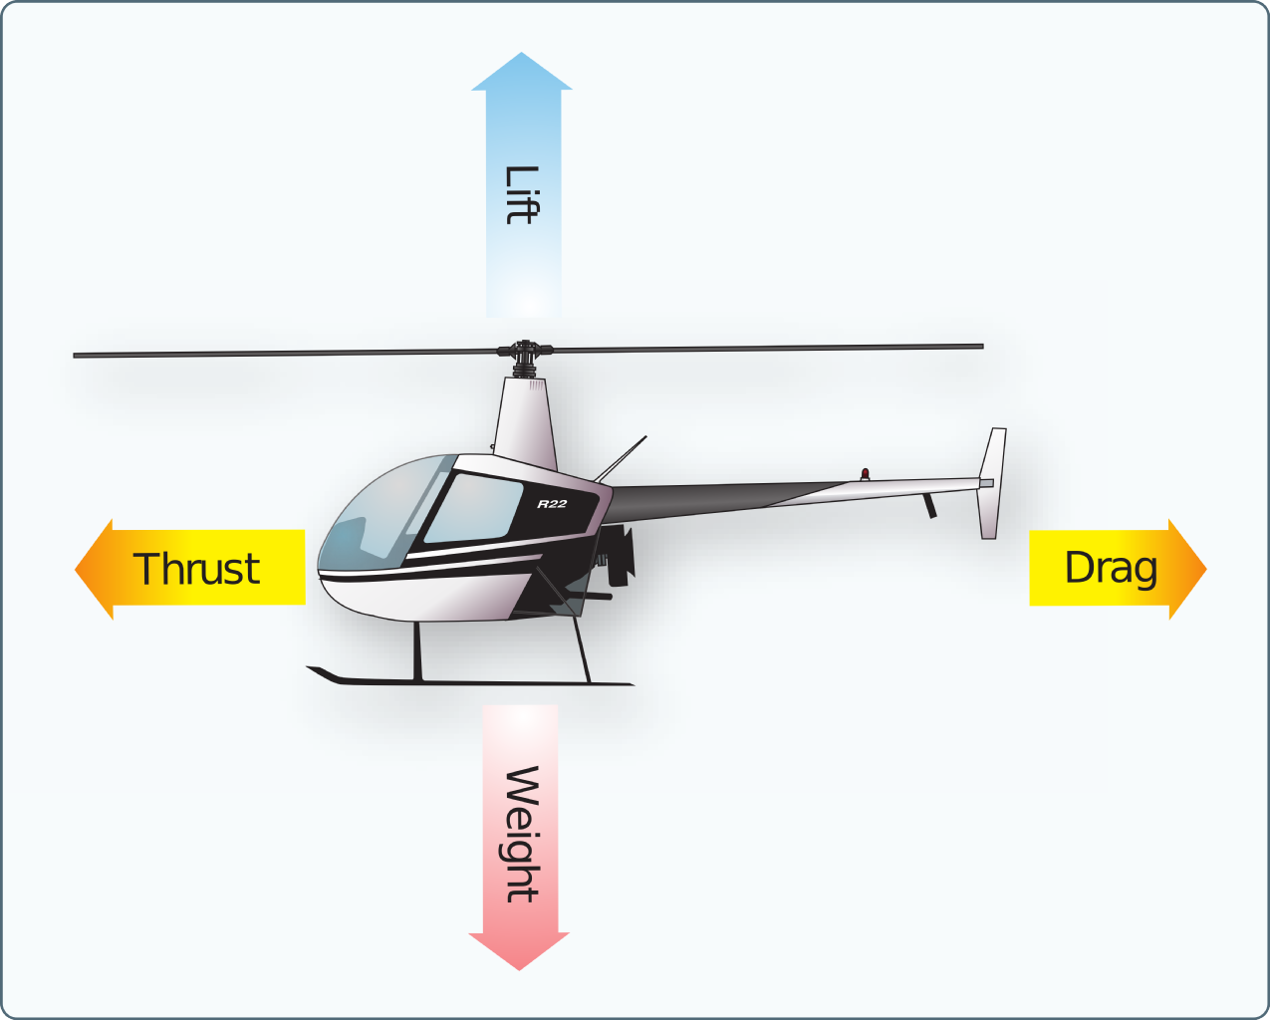

What Can A Helicopter Do?
Helicopters can do things airplanes cannot, like move straight up or down. Helicopters can also take off or land without a runway, and they can turn in the air in ways airplanes cannot. Helicopters can fly backward or sideways. They can also hover in one spot in the air without moving.

What Are Uses Of Helicopters?
Helicopters can be used for many things. They can be used as flying ambulances to carry patients. When loaded with water, they can also help fight large fires. Military forces use helicopters to move troops and get supplies to ships. Helicopters can move large objects from place to place, as well as rescue people in hard-to-reach places like mountains or in oceans. Television and radio stations use helicopters to fly over cities and report on traffic. Helicopters are used by police to see things, as well as by people on vacation to get a nice view.

How Can Helicopters Be Improved?
Engineers conduct research on ways to make helicopters better. Engineers study how new materials can keep passengers safe if a helicopter crashes through crash tests. Wind tunnel tests determine how to make helicopters quieter and more fuel-efficient. Wind tunnels are large tubes with air moving inside. The tunnels are used to copy the actions of an object in flight. Researchers use wind tunnels to learn more about how an aircraft will fly and make it more aerodynamic. Wind tunnels are used to test scale models of aircraft and spacecraft. Some wind tunnels are big enough to hold full-size versions of vehicles. The wind tunnel moves air around an object, making it seem like the object is really flying. New ideas could help engineers create bigger, better and faster helicopters. Someday helicopters could carry 100 people on trips of 300 miles or more. NASA is even designing helicopters that could be flown on Mars!

- ANCHOR 1: WHAT THE TEXT SAYS
Which sentence from the article shows that helicopters can help hospitals?
A
They can be used as flying ambulances to carry patients.
B
Military forces use helicopters to move troops and get supplies to ships.
C
Helicopters are used by police to see things, as well as by people on vacation to get a nice view.
D
Engineers study how new materials can keep passengers safe if a helicopter crashes through crash tests.

- ANCHOR 1: WHAT THE TEXT SAYS
Choose the paragraph from the article that suggests a lot of research goes into helicopter design. (The paragraph that starts with…..(use first 5 words))

- ANCHOR 5: TEXT STRUCTURE
Fill in the blank.
Overall, the article is organized around ........
A
the parts of a helicopter and how they are studied.
B
how helicopters are different from airplanes.
C
how helicopters function and how they are used.
D
the history of helicopters and how they have changed.

- ANCHOR 5: TEXT STRUCTURE
Which of the following answer choices BEST describes the structure of the section "What Can A Helicopter Do?"
A
chronological order
B
compare and contrast
C
problem and solution
D
cause and effect

