Still I Rise

Maya Angelou, 1928 - 2014

You may write me down in history
With your bitter, twisted lies,
You may trod me in the very dirt
But still, like dust, I’ll rise.

Does my sassiness upset you?
Why are you beset with gloom?
‘Cause I walk like I’ve got oil wells
Pumping in my living room.

Just like moons and like suns,
With the certainty of tides,
Just like hopes springing high,
Still I’ll rise.

Did you want to see me broken?
Bowed head and lowered eyes?
Shoulders falling down like teardrops,
Weakened by my soulful cries?

Does my haughtiness offend you?
Don’t you take it awful hard
‘Cause I laugh like I’ve got gold mines
Diggin’ in my own backyard.

You may shoot me with your words,
You may cut me with your eyes,
You may kill me with your hatefulness,
But still, like air, I’ll rise.

Out of the huts of history’s shame
I rise
Up from a past that’s rooted in pain
I rise
I’m a black ocean, leaping and wide,
Welling and swelling I bear in the tide.

Leaving behind nights of terror and fear
I rise
Into a daybreak that’s wondrously clear
I rise
Bringing the gifts that my ancestors gave,
I am the dream and the hope of the slave.
I rise
I rise
I rise

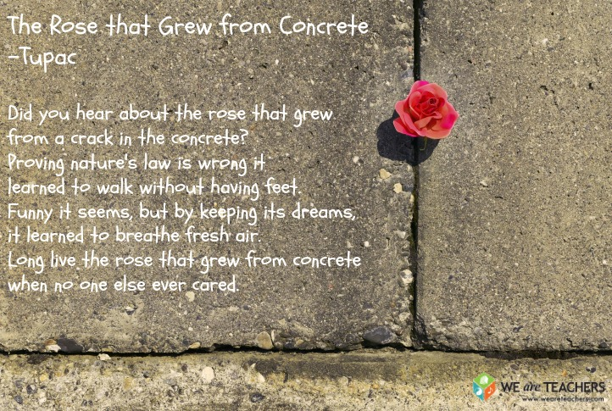

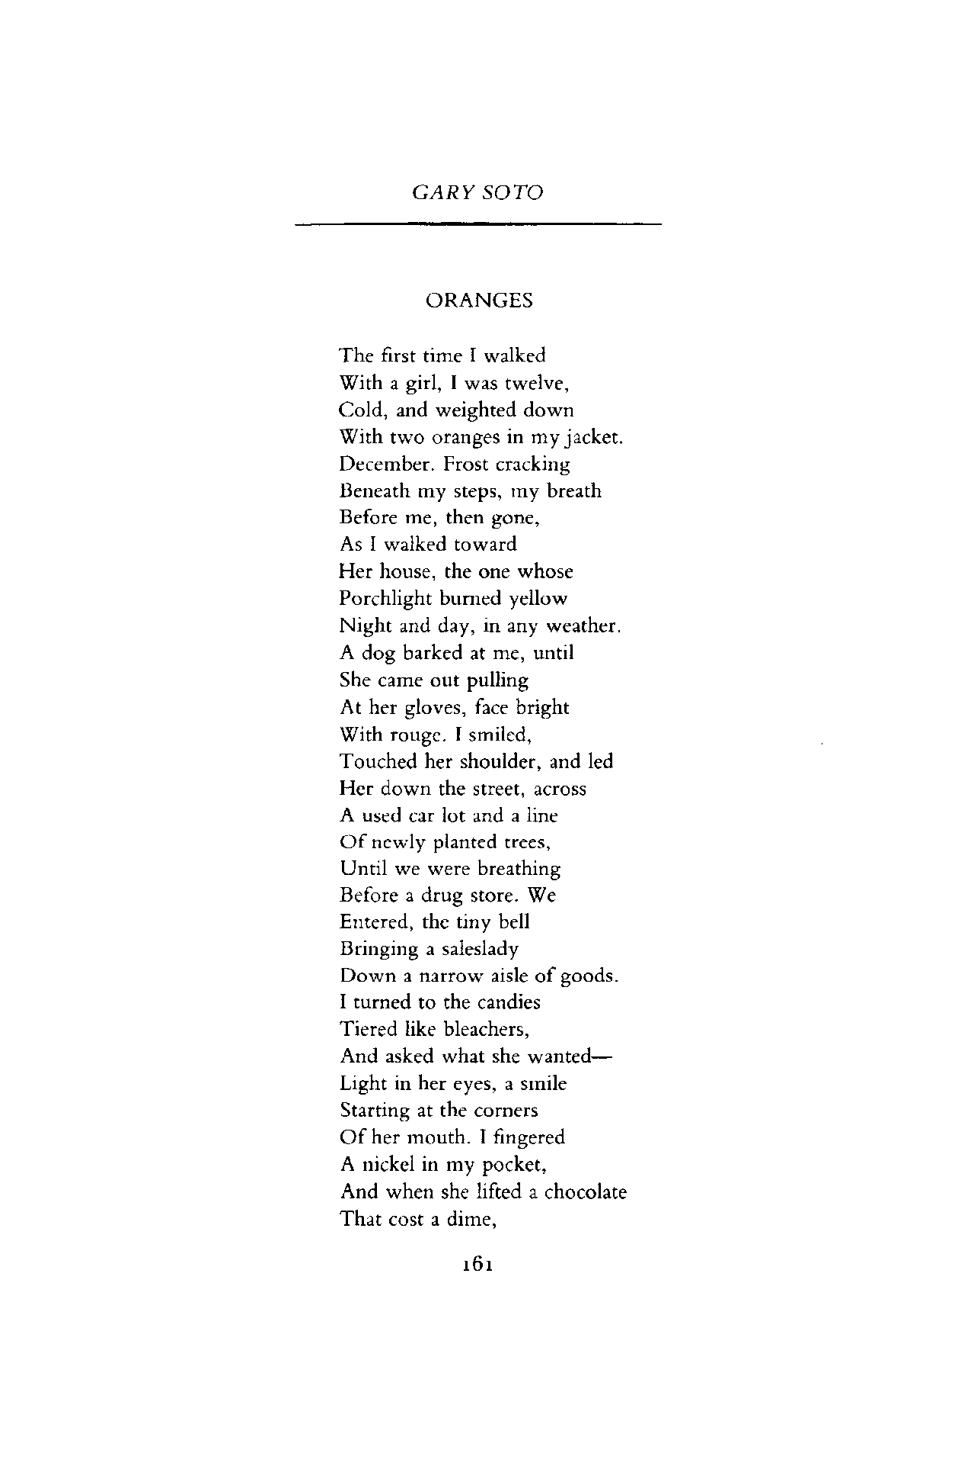

Graham Foust: And the Ghosts

they own everything

Annabel Lee
By Edgar Allan Poe

It was many and many a year ago,
In a kingdom by the sea,
That a maiden there lived whom you may know
By the name of Annabel Lee;
And this maiden she lived with no other thought
Than to love and be loved by me.

I was a child and she was a child,
In this kingdom by the sea,
But we loved with a love that was more than love—
I and my Annabel Lee—
With a love that the wingèd seraphs of Heaven
Coveted her and me.

And this was the reason that, long ago,
In this kingdom by the sea,
A wind blew out of a cloud, chilling
My beautiful Annabel Lee;
So that her highborn kinsmen came
And bore her away from me,
To shut her up in a sepulchre
In this kingdom by the sea.

The angels, not half so happy in Heaven,
Went envying her and me—
Yes!—that was the reason (as all men know,
In this kingdom by the sea)
That the wind came out of the cloud by night,
Chilling and killing my Annabel Lee.

But our love it was stronger by far than the love
Of those who were older than we—
Of many far wiser than we—
And neither the angels in Heaven above
Nor the demons down under the sea
Can ever dissever my soul from the soul
Of the beautiful Annabel Lee;

For the moon never beams, without bringing me dreams
Of the beautiful Annabel Lee;
And the stars never rise, but I feel the bright eyes
Of the beautiful Annabel Lee;
And so, all the night-tide, I lie down by the side
Of my darling—my darling—my life and my bride,
In her sepulchre there by the sea—
In her tomb by the sounding sea.

Do not go gentle into that good night
Dylan Thomas, 1914 - 1953
.
Do not go gentle into that good night,
Old age should burn and rave at close of day;
Rage, rage against the dying of the light.

Though wise men at their end know dark is right,
Because their words had forked no lightning they
Do not go gentle into that good night.

Good men, the last wave by, crying how bright
Their frail deeds might have danced in a green bay,
Rage, rage against the dying of the light.

Wild men who caught and sang the sun in flight,
And learn, too late, they grieved it on its way,
Do not go gentle into that good night.

Grave men, near death, who see with blinding sight
Blind eyes could blaze like meteors and be gay,
Rage, rage against the dying of the light.

And you, my father, there on the sad height,
Curse, bless, me now with your fierce tears, I pray.
Do not go gentle into that good night.
Rage, rage against the dying of the light.

